Crunchy Sesame Candy

Brown sugar and honey make these Asian candies an irresistibly sweet gift, especially when they're tucked into small, colorful boxes (sold in most craft stores) or paper jewelry boxes.
Ingredients

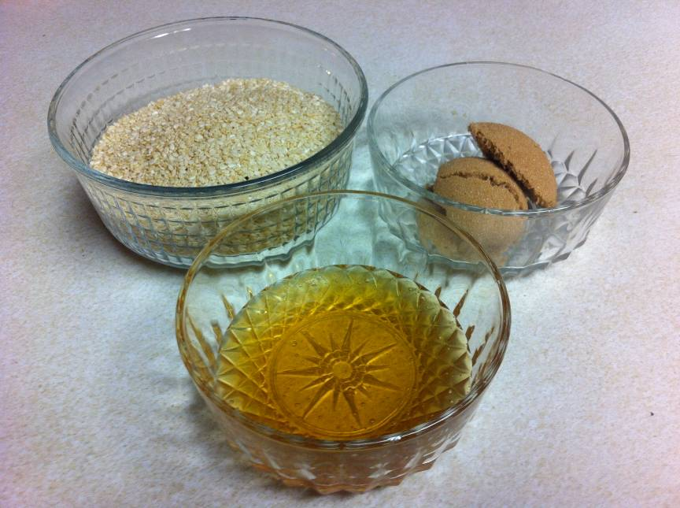
- 1 cup sesame seeds (about 6 ounces)
- 3 tablespoons packed light brown sugar
- 3 tablespoons honey
Instructions
- Generously coat two large sheets of waxed paper with cooking spray.
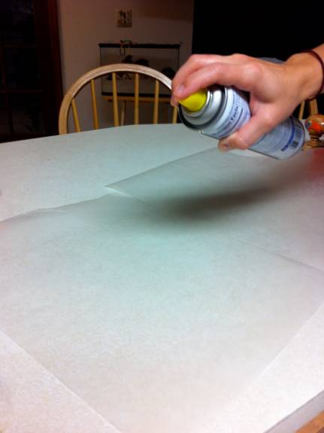
- In a medium skillet, toast the sesame seeds over medium-low heat, stirring often, until they're fragrant and golden, 5 to 7 minutes.
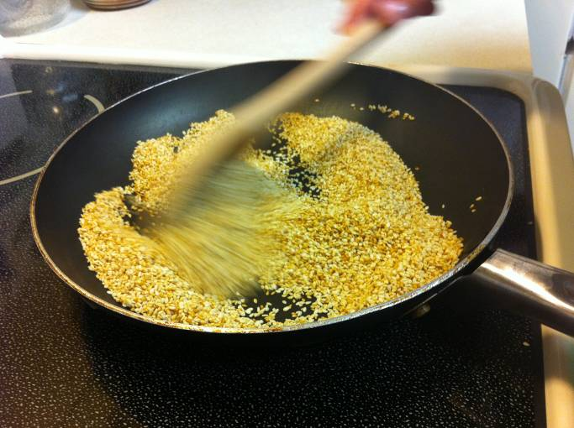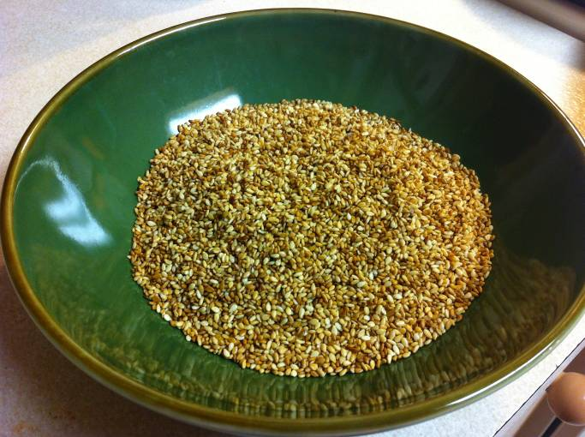
- In a small saucepan, combine the brown sugar and honey. Cook over low heat, stirring often, until the sugar is melted and the mixture is thick, about 5 minutes.
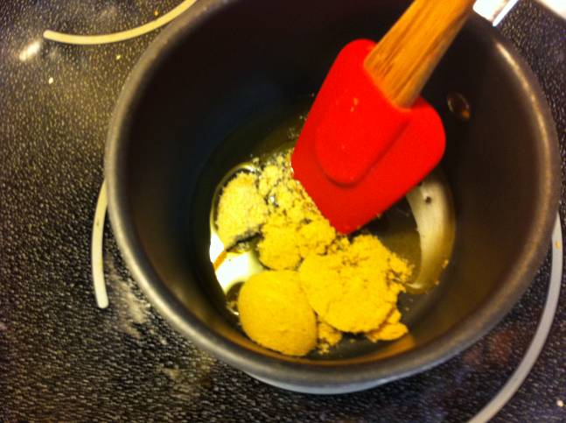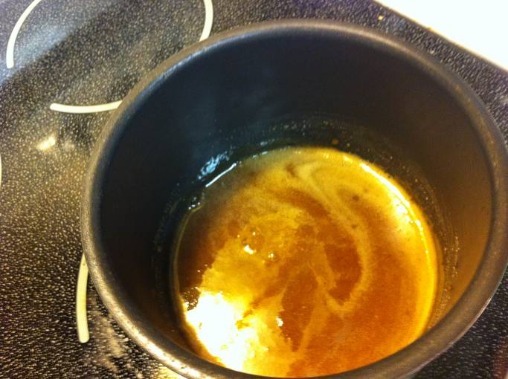

- Add the sesame seeds to the sugar and stir well with a wooden spoon.
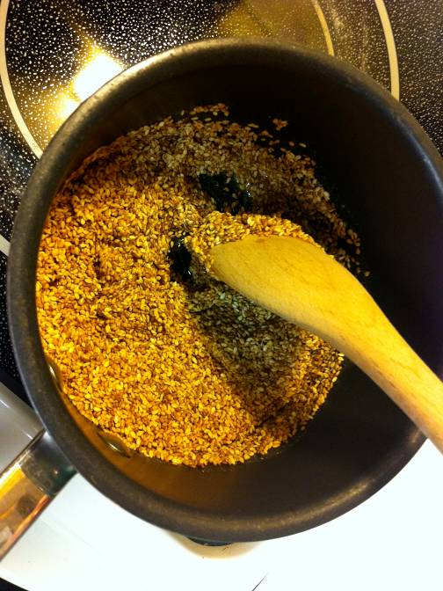
- Place one sheet of the waxed paper on a work surface, greased-side up. Scrape the mixture onto the paper and top it with the remaining sheet of waxed paper, greased-side down. Using a rolling pin, roll the mixture into a square about 1/4 inch thick.
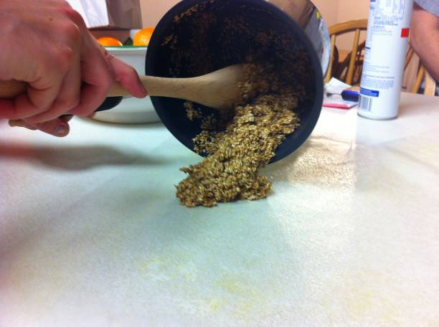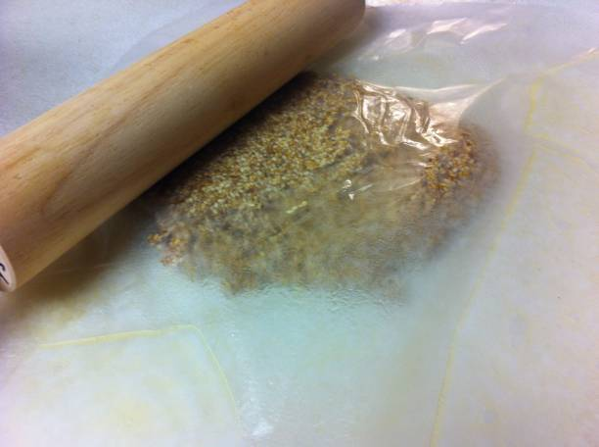
- Remove the top sheet of paper and cut the candy into 1-inch squares with a sharp knife. Let the candy cool completely. Break apart the pieces and store them in an airtight container at room temperature until you're ready to package them. Makes about twenty-four 1-inch squares.
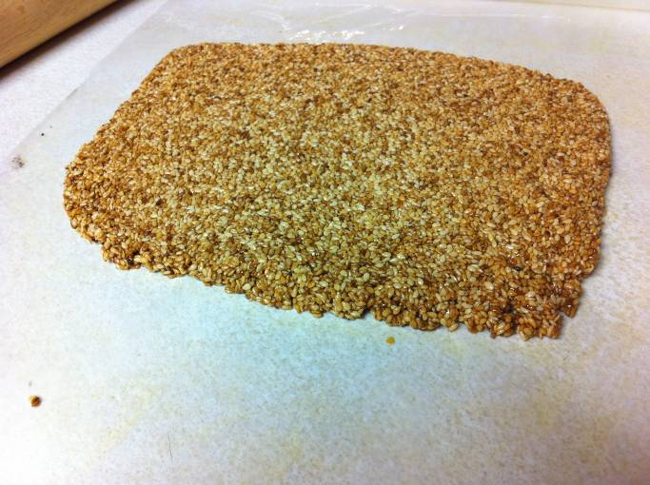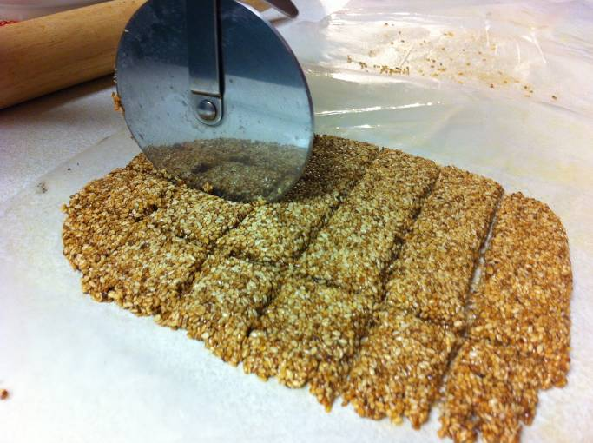

http://familyfun.go.com/valentines-day/valentines-day-recipes/valentines-day-candy-brownies/crunchy-sesame-candy-684269/

