Congratulations Fearless One, you have won the 2013 Spooktacular Fear Factor Competition!
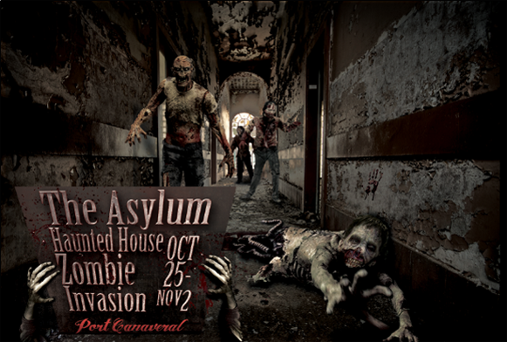
Since you obviously aren’t afraid of anything, your prize will test your will once more…you and a guest are officially invited to attend The Asylum Haunted House. Bring the ticket receipt (attached) to the box office to exchange for two Haunted House tickets.
Dates & Times
Sunday 10/27/13 – Weds 10/30/13: 7pm – 10pm
Thurs 10/31/13 – Saturday 11/2/13: 7pm – MIDNIGHT

Location
THE ASYLUM HAUNTED HOUSE
610 GLENN CHEEK DRIVE
PORT CANAVERAL, FL 32920

More Info
frightweek.com or facebook.com/frightweek

2013 Winner

